Richa Ankush Pathe | Principal | 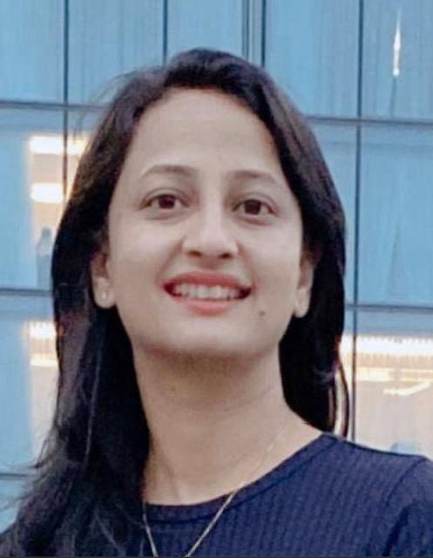
Vibha Joshi | Professor | 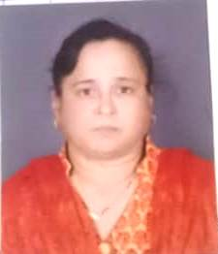
Sudhir Kumar Chandel | Professor | 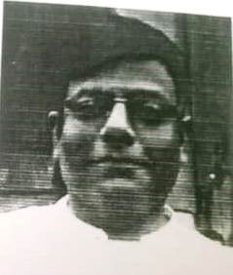
Waseem Mohammad | Associate Professor | 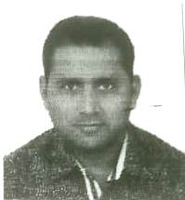
Pragya Mishra | Associate Professor | 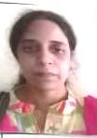
Humera Shoukat | Associate Professor | 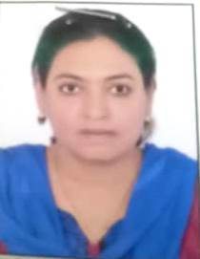
Ashok Kumar Shah | Assistant Professor | 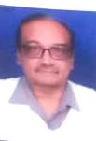
Manoj Misra | Assistant Professor
Minu Rai | Assistant Professor | 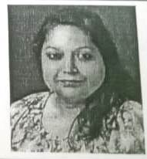
Sheena Shrivastava | Assistant Professor | 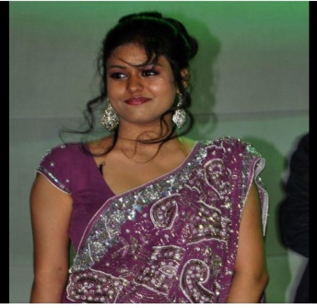
Nemisha Rajput | Assistant Professor | 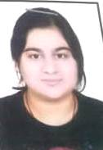
Meena Singh | Assistant Professor | 
Niharika Sehgal | Assistant Professor | 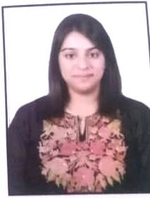
Shubham Dawande | Assistant Professor | 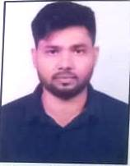
Pooja Singh Meena | Assistant Professor | 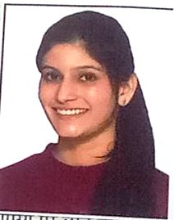
Aashutosh Nema | Associate Professor | 
Rahul Deo Upasani | Assistant Professor | 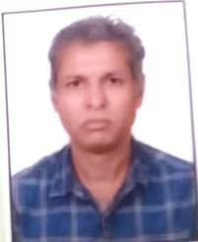
Saman Jameel | Assistant Professor | 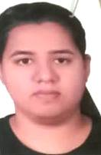
Tarun Yadav | Professor | 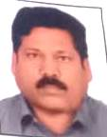
Sahil Khemani | Associate Professor | 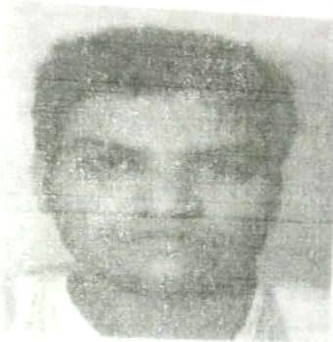
Ritesh Vishwakarma | Assistant Professor | 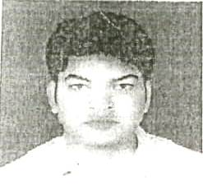
Priti Chandrabhan Tijare | Assistant Professor | 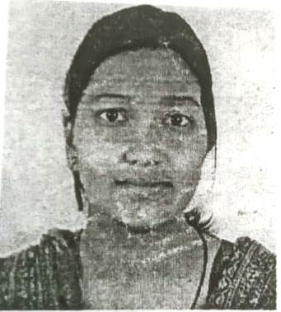
Shrutika Joshi | Assistant Professor | 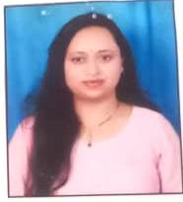
Gunjan Singh Sengar | Assistant Professor | 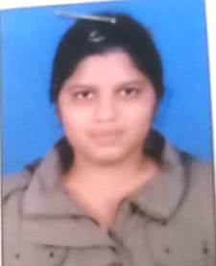
Samir Gupta | Assistant Professor | 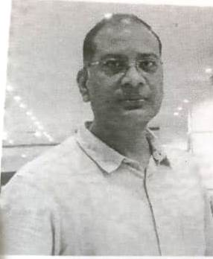
VIPIN KUMAR DWIVEDI | Assistant Professor

